Web-App User Guide
Version 3.0 – August 20, 2014


Contents
Version History 4
Goals of this Document 4
Introduction: The RTLM Difference 4
The Data Mining Lifecycle 5
Overview 5
Problem Definition 6
Data Preparation 6
Data Exploration 6
Modeling 6
Evaluation 7
Deployment 7
RTLM Key Concepts 7
Working with RTLM 7
Authentication 7
RTLM Web UI 8
Data Source 10
Encoder 10
Project 10
Exploration 10
Models 14
Classification Models 14
Regression Models 14
Model Reduction 14
Prediction 15
Assessment 15
Using RTLM 15
Authentication 15
Data Sources 16
Create Data Source 16
View Data Source 17
Delete Data Source 18
Encoder 18
Creation 18
View Encoder Metadata 20
Delete Encoder 21
Project 21
Creation 21
Additional Data 23
Learn/Forget 24
Create Model 25
Delete Model 27
New Assessment 28
New Prediction 30
Delete Project 31

Version History
Author | Version | Date | Note
mike | 2.91
neil | 2.9101

Goals of This Document
This user guide is intended for analysts using RTLM in their next data-mining project. While this document does not assume extensive background in data modeling, the reader should have a rudimentary understanding of data-mining methodology, as well as the necessary domain knowledge related to their field of application.
A brief introduction to data-mining concepts will be provided in this guide, along with instructions on applying these concepts to RTLM-specific workflows. The core intention of this document is to provide readers with a brief summary of the information needed to successfully implement RTLM into their data-driven projects and to cover typical usage scenarios.

Introduction: The RTLM Difference
Real Time Learning Machine (RTLM) is an application that allows organizations to leverage their existing data to gain further insight into their current business processes. Whether you are attempting to increase user clicks, select the most appropriate product, or analyze the relationship between various factors affecting your business, RTLM can offer you a real-time, scalable, and easy-to-deploy platform on which to build the next generation of data-driven applications within your organization.
A unique feature of RTLM is the adoption of the learn-once-model-endlessly approach to predictive analytics. This is done by the separation of the learning phase from model creation. By avoiding the complete data scan typically required by the majority of other systems, users are able to experiment with many different models, using a varying selection of attributes, and find the perfect combination of attributes for their particular task. The separation of learning and modeling also allows RTLM to account for new attributes dynamically, including increments and decrements. Adding new attributes is simply a matter of feeding new data into RTLM. If at some stage the data is found to be erroneous, removing these records from RTLM becomes simple. Experimenting with large datasets becomes a much more fluid and less time-consuming process, thus enabling faster deployments and a quicker time-to-market.

The Data-Mining Lifecycle

Overview
Data mining is about explaining the past and predicting the future by means of data analysis. While the term data mining is relatively new, the process it describes has been around for a long time. It simply refers to the utilizing of empirical data to gain further insight, thus being able to define a project and guide its development.
Below is a sequence of steps most commonly followed in any data-mining project, followed by an explanation of each step.

Problem Definition
Defining a data-mining problem requires a complete understanding of a project’s objectives and requirements from a domain perspective, and then converting that knowledge into a data-mining problem definition with a preliminary plan designed to achieve the objectives. Data-mining projects are often structured around the specific needs of an industry sector or even tailored and built for a single organization. A successful data-mining project starts from a well-defined question or need.

Data Preparation
Data preparation involves constructing a dataset from one or more data sources to be used for exploration and modeling. Best practice requires starting with an initial sample dataset to get familiar with the data, to discover first insights into the data, and to have a good understanding of any possible data quality issues. Data preparation is often a time-consuming process and heavily prone to errors. The old saying "garbage in, garbage out" is particularly applicable to those data-mining projects in which data gathered may contain invalid, out-of-range, or missing values. Analyzing data that has not been carefully screened for such problems can produce highly misleading results.

Data Exploration
Data exploration is the process of describing data by means of statistical and visualization techniques. The data is explored in order to bring important aspects of it into focus for further analysis.
RTLM provides functionality for both univariate analysis and multivariate analysis. Univariate analysis focuses on one attribute at a time and is an easy way to verify that the data has been imported correctly and is in line with the previous assumptions made by the analyst. Multivariate analysis, on the other hand, allows for the study of many attributes and the relationships between them. For example, are certain attributes correlated? Do values of one attribute show statistical dependence on the values of another? These questions can generally be answered with the help of multivariate analysis and will guide the attribute choice for the final model.

Modeling
Predictive modeling aims to use historical data in order to predict the probability of some unknown event. If the unknown outcome is categorical (e.g., click vs. non-click), you are solving a classification problem and will need to build a classification model. In other words, you are trying to classify a particular case into the most appropriate group. A regression model, on the other hand, attempts to predict the value of a continuous variable. An example of this could be the average bag value of a customer or average house price in a particular area.

Evaluation
Model evaluation is an integral part of the model-development process. It aids in finding the best model that represents the process and in presenting how well the chosen model will work in predicting future outcomes. A common approach to performing model evaluation is to separate the historical data into two parts. The first part, often the larger of the two, will serve as the training set. This part will be used to build the model. The remaining part, typically referred to as the test set, will be left out until the model-building process is complete. After the model is ready, its performance can be evaluated with this test set. The outcomes for the test set are known in advance. Evaluating the model simply involves keeping a tally of the number of times it correctly predicts the outcomes of the test set.

Deployment
The concept of deployment in predictive data mining refers to the application of a model for prediction of new data. Building a model is generally not the end of the project. Even if the purpose of the model is to increase knowledge of the data, the knowledge gained will need to be organized and presented in a way that can be used. Depending on the requirements, the deployment phase can be as simple as generating a report or as complex as implementing a repeatable data-mining process. In many cases, it will be a developer, not the data analyst, who will carry out the deployment steps. However, even if the analyst will carry out the deployment effort, it is important for the developer to understand up front what actions will be needed to actually make use of the created models.

RTLM Key Concepts

Working with RTLM
RTLM offers users two separate ways of accessing its core functionality: RTLM Web and RTLM REST. RTLM Web offers a complete GUI for accessing some of the most common functionality. It allows the user to add data, learn, and build predictive models on that data. Most of the functionality available in RTLM Web can be replicated via individual calls in RTLM REST. For a detailed description of RTLM REST and how it can help you simplify deployment, please consult the RTLM REST API guide.

Authentication
In order to access RTLM Web functionality, a user must log in with a predefined set of credentials. The process of generating these credentials is explained further in the Using RTLM section of this document. Additional administration of user credentials is covered in the RTLM admin user guide.

RTLM Web UI
Upon logging in to RTLM Web, the user will be presented with an interface that enables him or her to fully leverage the functionality of RTLM (Figure 1). The interface of RTLM Web is broken down into three main components: main accordion, contextual panel, and the user admin panel. Within these panels, the user is able to interact with various RTLM objects (e.g., models, data sources, encoders, etc.).
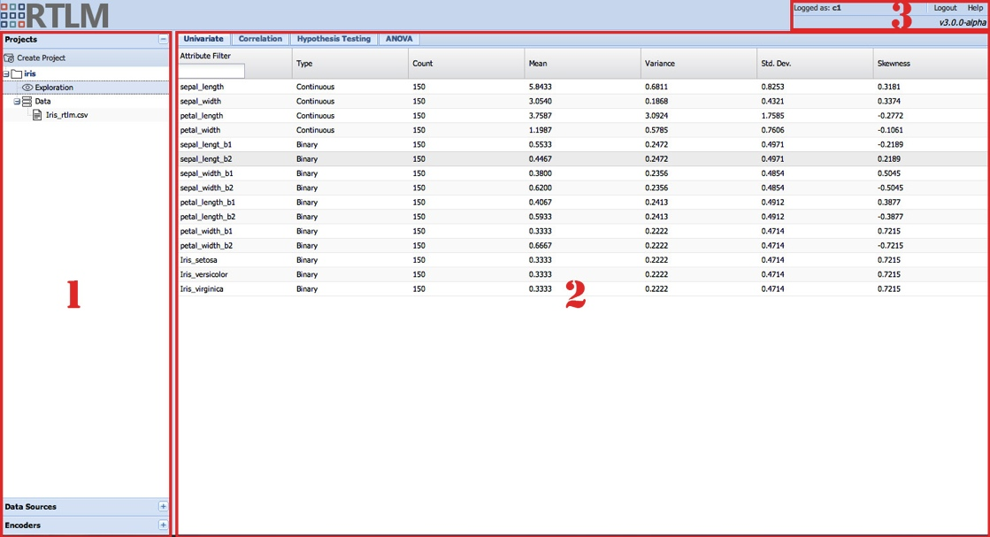
Figure 1 - RTLM Main UI Components: 1 – Main Accordion; 2 – Contextual Panel; 3 – User Admin Panel

The main accordion provides a quick overview of data sources, encoders and current projects (Figure 2). The Data Sources panel, when expended, will give you a general overview of the data sources currently registered with RTLM. This allows you to validate and delete various data sources used within your project. Under the Encoders panel, you will have access to the encoders used throughout your projects. Finally, the Projects panel gives you access to the heart of RTLM: the RTLM project. Here you will be able to learn and explore new data, build and evaluate your models as well as make predictions.

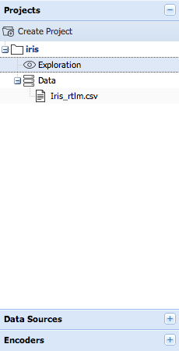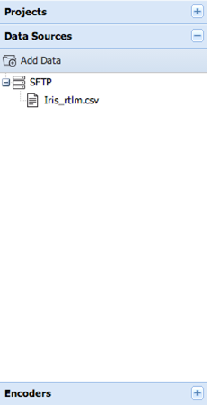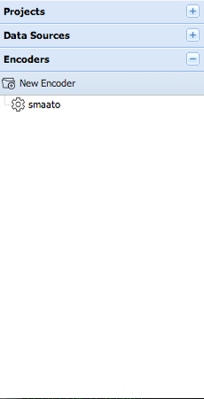
Figure 2 - Accordion Panel Changes
The details of specific RTLM objects can be viewed in a contextual panel (Figure 3). For instance, double-clicking on a learned project object will show various multiple univariate statistics as well as give the user an opportunity to perform hypothesis testing and analysis of variance (ANOVA) exploration.
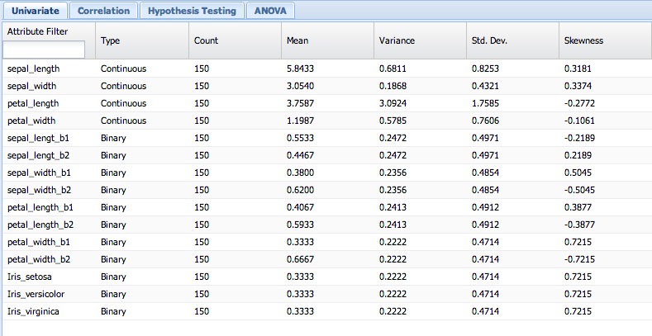
Figure 3 - Contextual Panel

The user admin panel simply displays the active user and the current version of the RTLM application (Figure 4). Within this panel you will also receive notifications about latest version updates.
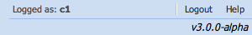
Figure 4 - User and Version Information.

Data Source
The first step when working with RTLM is to define a data source. Data-source objects are typically flat text files that are stored at a remote location. In the current implementation of RTLM, the remote location can either be an SFTP server, HTTP server, or an Amazon S3 object. After registering a particular data source with RTLM, a user should have everything RTLM needs to learn from the newly-added data.
CSV is the only supported format for flat files.

Encoder
In data mining, the process of transforming a categorical variable into a numerical variable is called encoding. Within RTLM, an encoder object allows the user to transform high-cardinality attributes into meaningful data that is predictive in nature.

Project
Within RTLM, a project is simply a top-level container for a collection of data files, models, prediction results, and assessment results. While no particular convention is enforced, it is recommended that the project contain elements closely related to a particular initiative.

Exploration
After data has been added and is learned, a user should be able to use the explore feature of RLTM Web to verify that his or her data has been processed correctly. In other words, a project becomes explorable after a data source has been added to it and learned. Using univariate and bivariate analyses, a user can determine the likely selection of candidate pairs that will provide insight for model building. Within RTLM, tools for exploratory analysis are accessed via various tabs in the contextual panel.
The Univariate panel (Figure 5) shows the basic statistics for attributes from a particular data source. Viewing the information in this panel serves as a quick sanity check and validation of whether the data has been correctly interpreted by RTLM.
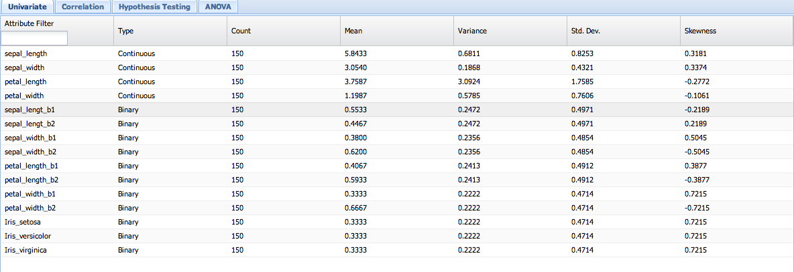
Figure 5 - Univariate Panel

Correlation panels (Figures 6 and 7) allow you to perform bivariate analyses on the learned data. This enables you to quickly learn about the degree of associativity between your variables and aid you in the creation of subsequent models. In general, models with highly-correlated variables should be avoided. In other words, if variable A is highly correlated with variable B, only one should be chosen for the final model.
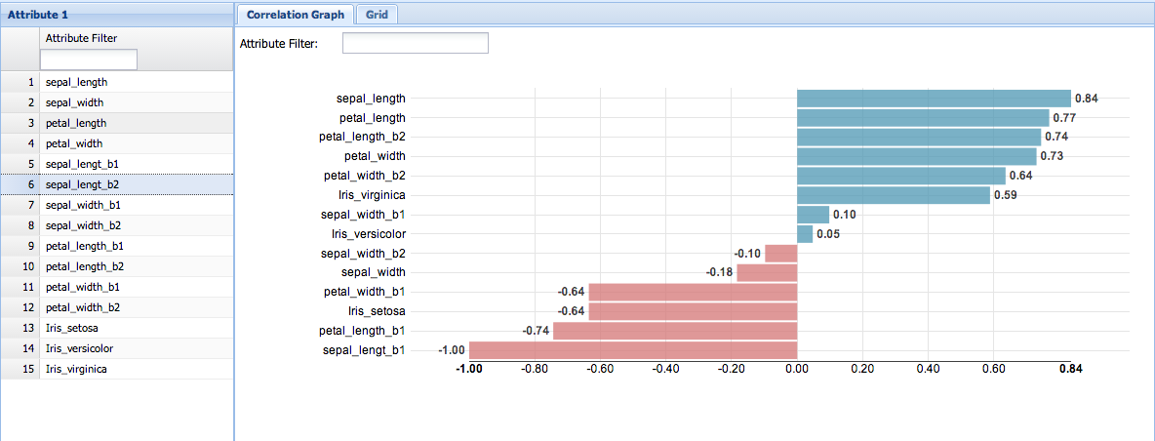
Figure 6 - Correlation Panel – Graph

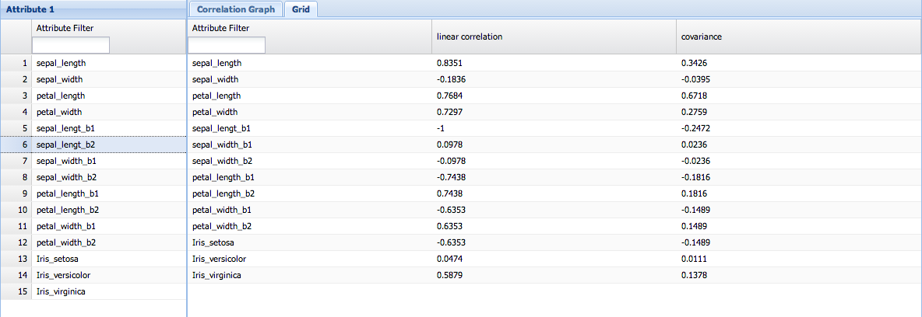
Figure 7 - Correlation Panel – Grid

Hypothesis testing (Figure 8) allows for a more formalized way of determining the effect of various inputs on your continuous target. From this you will able to determine if the difference in the continuous variable is related to the values of the binary variables.
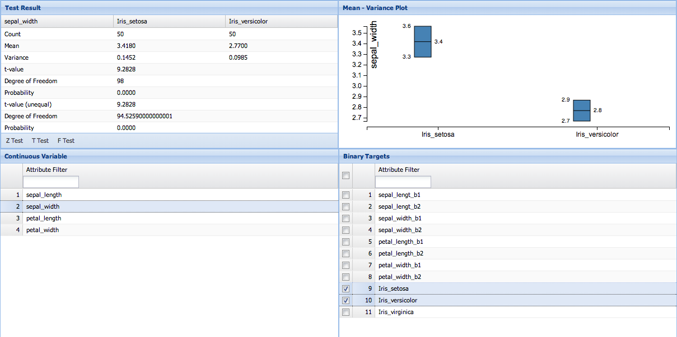
Figure 8 - Hypothesis Testing
Like a correlation analysis, hypothesis testing is a way of performing a bivariate analysis and assessing how variables interact with each other. While correlation looks at how high values of variable A correspond to high values of variable B and low values of A correspond to low values of B, hypothesis testing is a more formal method of determining whether values of one variable are dependent on values of another variable. When you have two numerical variables, correlation testing is more likely to be used. With two categorical variables, you would more likely use hypothesis testing. If one variable is categorical and the other is numerical, ANOVA (see next subsection) would be the best choice.

The Z Test assesses whether the difference between the averages of two attributes is statistically significant. This analysis is appropriate for comparing the average of a numerical attribute with a known average or two conditional averages of a numerical attribute given two binary attributes (two categories of the same categorical attribute).
The T Test, like the Z Test, assesses whether the averages of two numerical attributes are statistically different from each other when the number of data points is less than 30. The T Test is appropriate for comparing the average of a numerical attribute with a known average or two conditional averages of a numerical attribute given two binary attributes (two categories of the same categorical attribute).
The F Test is used to compare the variances of two attributes. The F Test can be used for comparing the variance of a numerical attribute with a known variance or two conditional variances of a numerical attribute given two binary attributes (two categories of the same categorical attribute).

The final panel in the exploration context is ANOVA (analysis of variance, Figure 9), which assesses whether the averages of more than two groups are statistically different from each other, under the assumption that the corresponding populations are normally distributed. ANOVA is useful for comparing averages of two or more numerical attributes or two or more conditional averages of a numerical attribute given two or more binary attributes (two or more categories of the same categorical attribute).
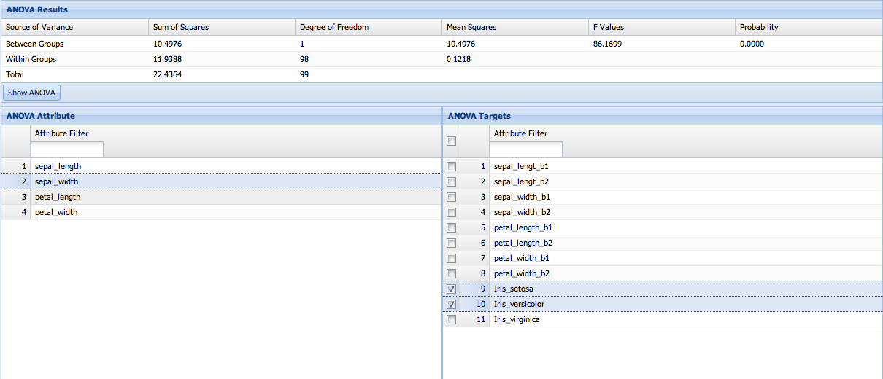
Figure 9 – ANOVA

Models
Unlike most systems, RTLM separates the tasks of learning and model building into two discrete steps. The classical approach assumes these two steps are synonymous by defining model building within the actual learning phase. RTLM achieves the separation by scanning the input data in such a way as to defer model creation to a later stage. This allows RTLM to reduce the memory footprint required to learn large data sets and allows models to be created instantaneously. Once the data has been learned, RTLM can generate both classification and regression models.

Classification Models
Classification refers to the data-mining task of attempting to build a predictive model when the target is categorical. The main goal of classification is to divide a dataset into mutually-exclusive groups so that the members of each group are as close to one another as possible, and different groups are as far from one another as possible.

Types of classification:
LDA: Linear discriminant analysis.
QDA: Quadratic discriminant analysis.
LSVM: Linear support vector machine.

Regression Models
Regression refers to the data-mining problem of attempting to build a predictive model when the target is numerical. The simplest form of regression, simple linear regression, fits a line to a set of data.
Types of regression:
MLR: Multi-linear regression.
LSVR: Linear support vector regression.

Model Reduction
RTLM also has the capability to reduce models; to automatically find a model with the best subset of attributes. This is useful when dealing with datasets with many attributes. RTLM uses a heuristic to build various models. It then compares the models and will keep the best one. This comparison is done efficiently by using the intrinsic values of the models. On the other hand, not all modeling algorithms are suited for this type of intrinsic-value comparison, and these techniques will only work when building LDA and MLR algorithms.

Prediction
After the models have been created, they are available to use for prediction. As with many pieces of functionality within RTLM, prediction can be done either through a RESTful service or with the RTLM Web application

Assessment
Once your project has been created, data has been added and learned, and the model has been built, you can test the accuracy of the model by inputting past historical data that was not used during the learning. You can then proceed to “hide” the correct value of the target attribute from the model and have it predict the outcome. By comparing the answer provided by the model with the actual result, and counting the number of times the model made the correct guess, you can assess the accuracy of the model. RTLM does all of this automatically just by providing a historical dataset that was not used for learning purposes.
RTLM Web provides basic functionality that supports split validation. Feeding labeled data into RTLM Web will produce a confusion matrix and gain chart that can be used to assess the performance of the models.

Using RTLM

Authentication
Logging in to the RTLM application is done with a predefined user ID and security key (Figure 10). The randomly generated security key was given to you when you initially registered for the application.
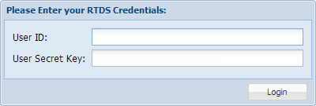
Figure 10 - Login Screen

Data Sources

Create Data Source
1. To create a new data source, click the button. You will be presented with a New Data Source wizard (Figure 11).

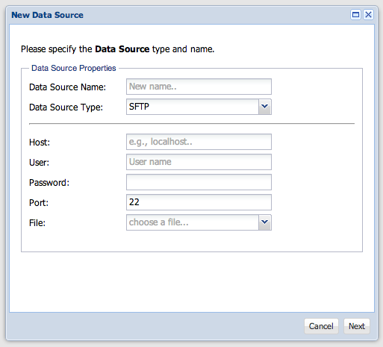
Figure 11 – SFTP Data Source Wizard
2. Select the preferred Data Source Type. The wizard forms will change depending on the type selected (Figures 12 and 13).
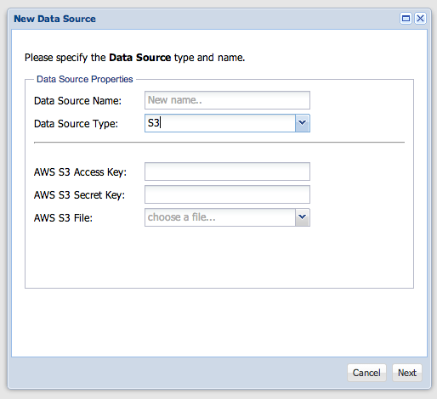

Figure 12 – SFTP Data Source Wizard
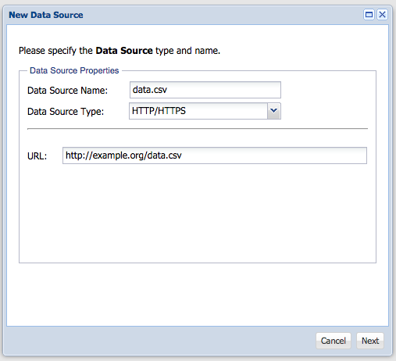
Figure 13 – HTTP Data Source

3. Ensure the validity of your data source (Figure 14).
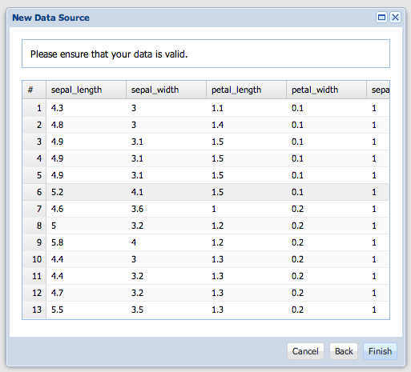
Figure 14 - New Data Source
4. Click to continue.

View Data Source
1. To view your newly created data source, double-click on its icon.
2. Inspect your newly-added data (Figure 15).
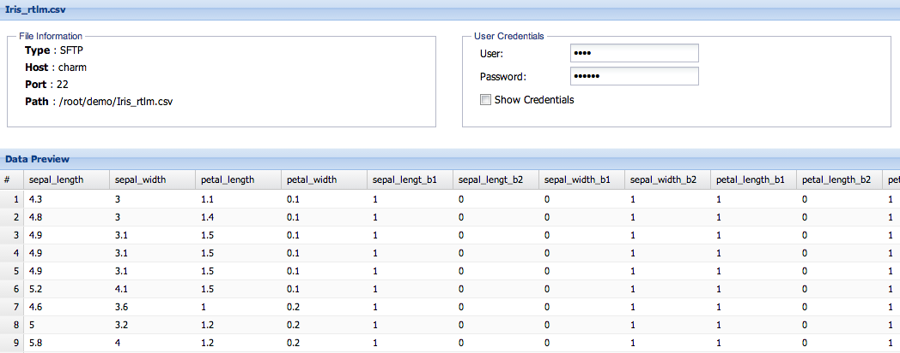
Figure 15 - Data Source Preview

Delete Data Source
To delete a data source, right-click on the node and select the Delete option (Figure 16).
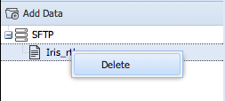
Figure 16 - Data Source Contextual

Encoder

Creation
1. To create a new encoder, click the button. You will be presented with a New Encoder wizard (Figure 17).
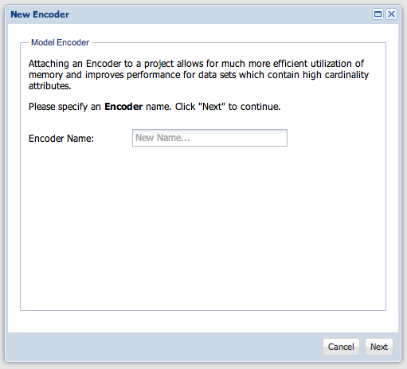
Figure 17 - New Encoder
2. Give your encoder a new name. Click Next to continue.
3.

Select an appropriate data source (Figure 18). Click Next to continue.
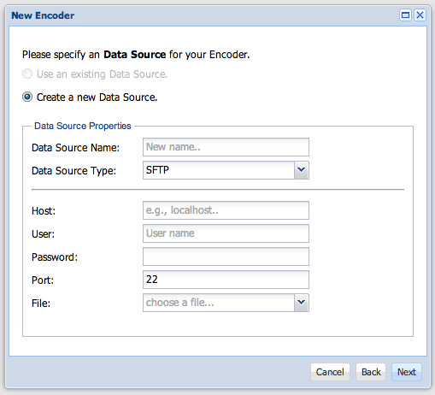
Figure 18 - Encoder Data Source
4. Ensure that your data is valid (Figure 19). Click Next to continue.
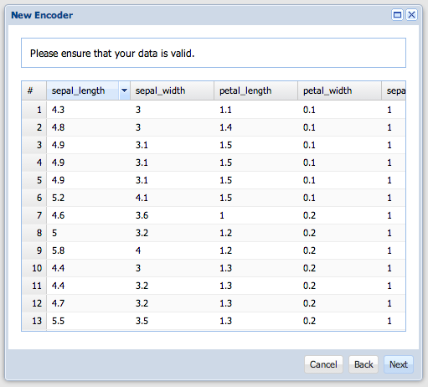
Figure 19 - Encoder Data Preview
5. Select the appropriate target variable (Figure 20). Click Finish to continue.
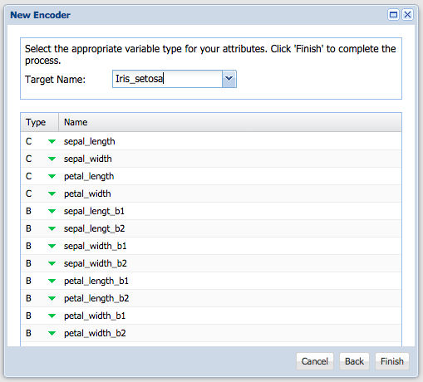
Figure 20 - Encoder Target Mapping

View Encoder Metadata
Double-click on the encoder to view its metadata (Figure 21).
Figure 21 - Encoder Tree

Delete Encoder

Right-click on the encoder icon and select Delete to remove the encoder from your project (Figure 22).
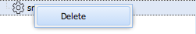
Figure 22 - Encoder Delete

Project

Creation
1. To begin the project creation process, click the button. Click Next to continue.
2. Give your project a new name (Figure 23). You can optionally assign an encoder to your project. Click Next to continue.
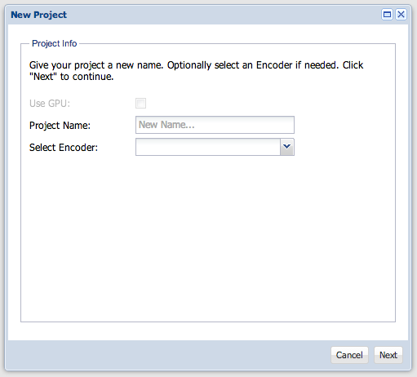
Figure 23 - New Project
3. Select an existing data source (Figure 24). Or, if you so choose, you can define a brand new data source directly from the project wizard.
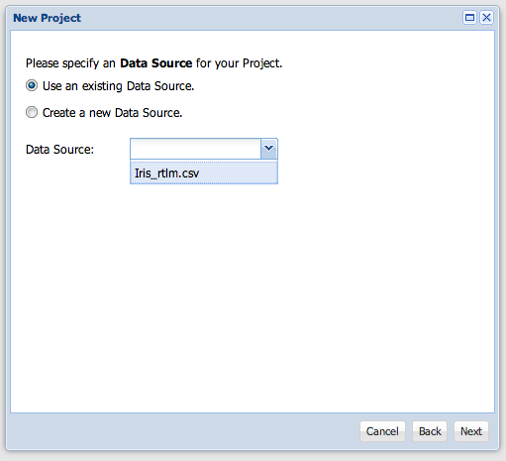
Figure 24 - New Project Data Selection
4. Ensure your data is valid (Figure 25). Clicking Next will take you to the type-mapping panel.
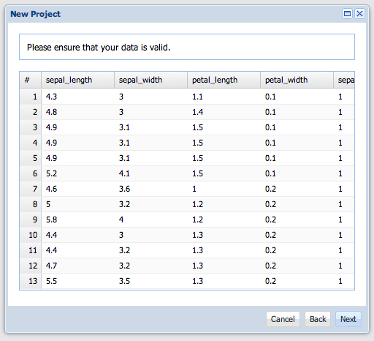
Figure 25 - New Project Data Preview
5. On the type-mapping panel (Figure 26), please verify the data types for the attributes inside the file. You also have the option of changing the data types to those you believe are more appropriate. Click Finish to start the project-creation task.
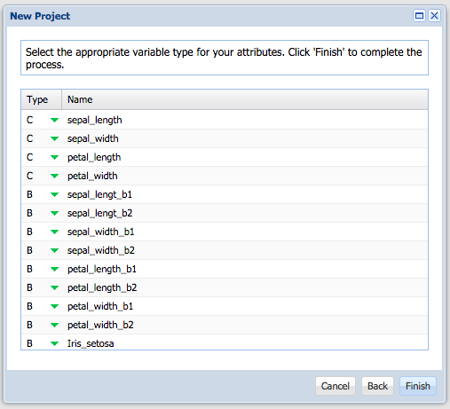
Figure 26 - Type Selection
6. After project creation is completed, you should see this change reflected in the projects panel (Figure 27).
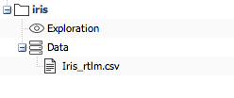
Figure 27 - Project Tree

Additional Data
An existing project can be augmented with additional data at a later stage. This could be an output of a weekly ETL process that constantly updates the file for use within RTLM.

1. Right-click on the Exploration node of your project tree (Figure 28). Select Add Data.
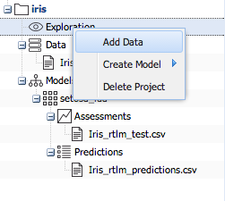
Figure 28 - Project Tree Add Data
2. Specify whether you are using an existing or a new data source. Click Next to continue.
3. Inspect your data. Ensure that it has been read properly. Click Next to add the data to your project.

Learn/Forget
After you have added a new data source to your project, you can either learn from this data or simply forget the records.
1. To learn a newly-added data source, simply right-click on the data-source node within your project tree (Figure 29). Select Learn.
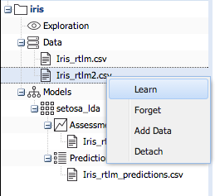
Figure 29 - Project Tree Learn
2. Forgetting a data source is performed in a similar manner (Figure 30). Right-click on the data source node and select Forget.
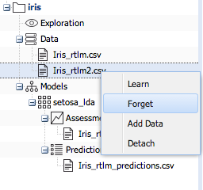
Figure 30 - Project Tree Forget

Create Model
Model building becomes available after the project-creation step is complete. With models, you can leverage the historical data learned within the project to make predictions about the future.
1. To begin the model creation process, right-click on the Exploration icon and select the type of model appropriate for you needs (Figure 31).
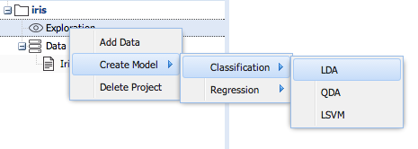
Figure 31 - Project Create Model
2. You will then be greeted with the Create Model Wizard (Figure 32). Give your model a new name and optionally specify any available reducer properties. Click Next to continue.
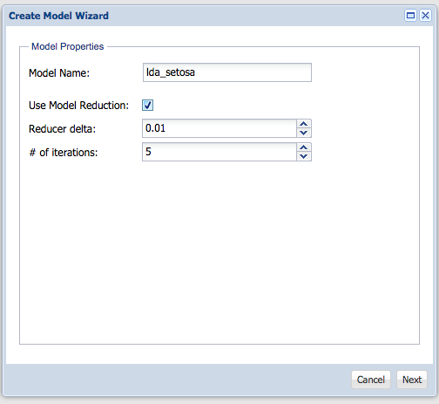
Figure 32 - Create Model
3. Select the attributes you will use as inputs as well as the attribute that will act as the target (Figure 33). Click Build Model to continue.
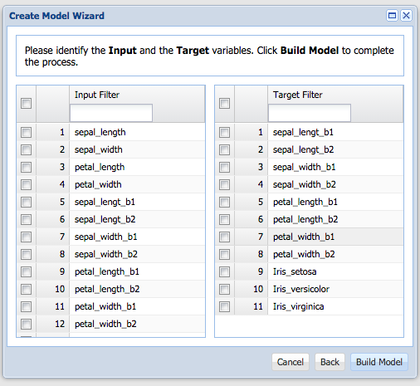
Figure 33 – Model-Type Selection

Upon completion of the model-building process, you will be presented with the option of seeing the results (Figure 34).
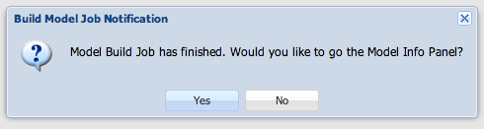
Figure 34 - Model Build Confirmation

Delete Model
Removing a model is as simple as right-clicking on the model node and selecting Delete Model (Figure 35).
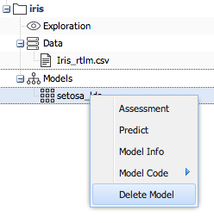
Figure 35 - Project Tree Delete

New Assessment
The performance of a model can be assessed using a labeled file.
1. To start the assessment, right-click on the Models icon and select Assessment (Figure 36).
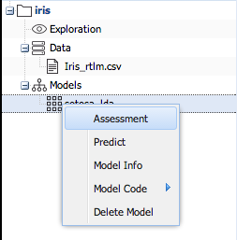
Figure 36 - Project Assessment
2. Specify the input data source you will use for the assessment. Click Next to continue.
3. Verify the data source you have added. Click Next to continue.
4. The final step is to ensure that the target variables of your model are mapped to the target variables of your file (Figure 37).
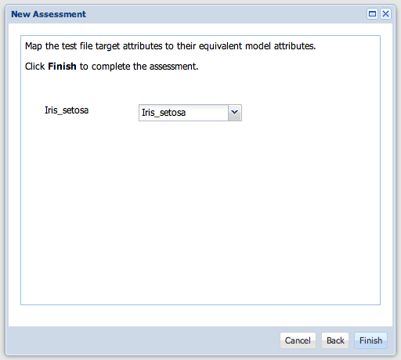
Figure 37 - New Assessment
5. Click Finish to start the assessment process.
Once the assessment process finishes, you will be presented with a dialog asking you if you want to see the result of the assessment. If you select Yes, you will be taken to the assessment information panel (Figure 38).
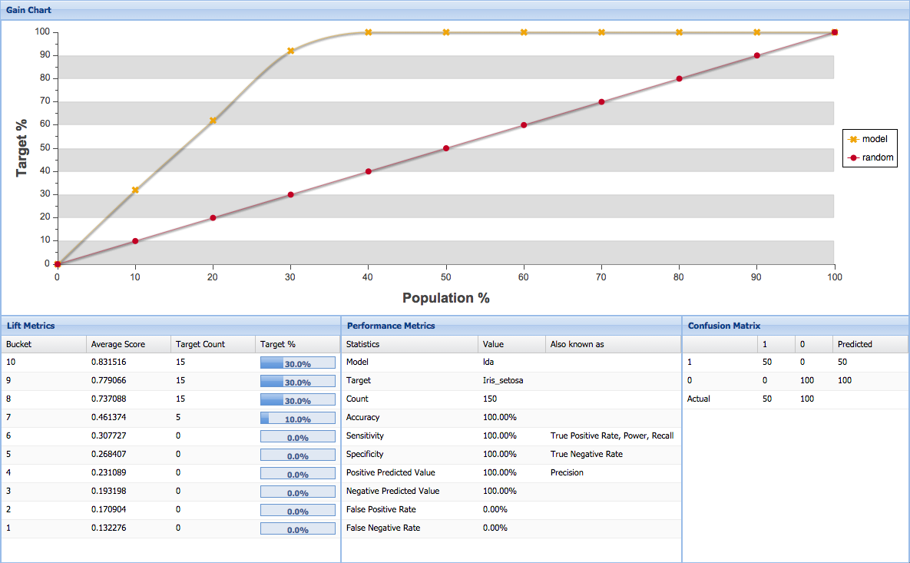
Figure 38 – Assessment Result

New Prediction
In addition to performing an assessment, an existing model can be used for predictions against a file.
1. Right-click on the Models node and then select Predict (Figure 39).
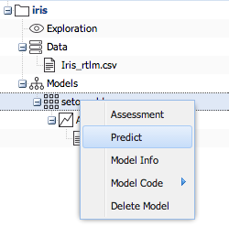
Figure 39 - Predict
2. Specify the input data source. Click Next to continue.
3. Specify the output data source, which is the location where you want your predictions saved. Click Next to continue.
4. You will be presented with the preview of the input data source. Verify that the data source has been read correctly. Click Next to continue.
Upon completion of the prediction process, you will be presented with the sample of the prediction result. You will be able to download the entire prediction file by clicking on the CSV Export button (Figure 40).
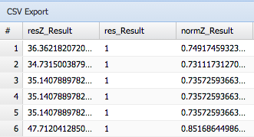
Figure 40 - Prediction Export

Delete Project
To delete a project, simply right-click on the project node and select Delete.

